**For Immediate Release**

**KELLI WELLI**

**NEW RELEASE: *SWEET DREAMS* (SINGLE)**

**PRODUCED by JOHNNY CLAY of ANTS ANTS ANTS**

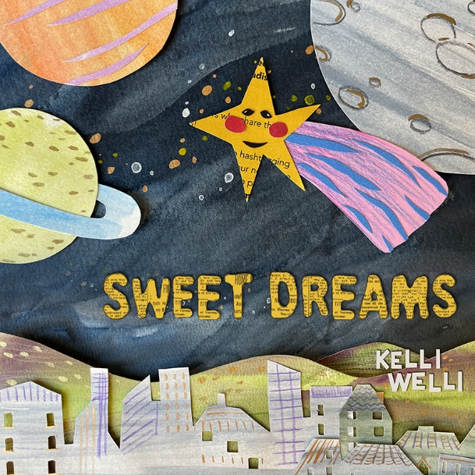

Song Details: ***Sweet Dreams***

Song release date:March 28, 2025

Label: 1st + 1st Media

For all ages, but especially for ages 0-14

Song run time: 03:41

Press download: <https://www.kelliwellikids.com/press>

**PORTLAND, OR (March 28, 2025)** – ***New Music Release!* Kelli Welli**, award-winning Children’s songwriter, recently recognized by the International Songwriting Competition and the John Lennon Song Contest, releases a genuine, heartwarming, and uplifting song about exploration in dreams. Written for one of her twins, who struggled with bad dreams when he was a little guy, in this song, we ask, “Where shall we go tonight in our dreams?” imagining the best adventures we can together, and we try to take charge of our dreams when they turn dark. Kelli draws on real, proven techniques she and her son learned to prepare for and try to change the course of bad dreams.

To have this special song produced, **Kelli** reached out to the uber talented **Johnny Clay** of kindie band **Ants Ants Ants** and folk pop band **The Dimes** — and he agreed to bring this lovely song to life, infused with the loving approach he takes with all of his own children’s music, knowing how precious and important it is to mark these moments with our children and support them through all of their journeys.

“I was so grateful when **Johnny** agreed to make this song for me. It’s such a meaningful one and I love the harmonies and wonderful energy I’ve heard in his work over the years” says **Kelli Welli**. “I also appreciated his leadership and patience, encouraging me to finger pick on acoustic guitar for my son’s song, a new step for me in recording.”

For the cover art, **Kelli** is so pleased to showcase the incredible paper art talent of **Shelley Hanmo** of **Junonia Arts**, an artist whose textured and innovative work **Kelli** has admired for some time. **Shelley** is a self-taught freelance illustrator and paper artist based in Indianapolis, who specializes in creating children’s book illustrations and editorial designs.

**ABOUT KELLI WELLI: Kelli Welli** (aka Kelli Caldwell) has been called “The Pixar of Children’s songwriters” for her award-winning work and commitment to keeping even the silliest of songs super smart, with full respect for kids’ brains. Recently named the Grand Prize Winner in the John Lennon Songwriting Contest and Top 3 in the International Songwriting Competition, **Kelli** draws upon her unique upbringing to create songs that often defy categorization. **Kelli’s** wide-ranging songwriting is clever, fun, often hilarious, sometimes reflective and deeply sweet. Always genuine. **Kelli’s** released four full albums in the last four years and can be heard on SiriusXM Kids Place Live. Her newest endeavors also include short film making, with inclusion in over 30 film festivals world-wide, including the Sonoma Film Festival, San Diego Comic Con, Children’s Film Festival of Seattle, and Portland’s one-of-a-kind gem, the Hollywood Theatre at PDX Airport. KELLIWELLI.COM

**ABOUT JOHNNY CLAY:** Leader of the folk pop band **The** **Dimes**, **Johnny Clay** has enjoyed a run of buzz fueled by his unique ability to craft catchy pop songs framed around fascinating historical themes and lyrics, as best demonstrated on the band’s 2009 release, “The King Can Drink the Harbour Dry.” In 2018, Clay formed the kindie band **Ants Ants Ants** with fellow singer/songwriters **Dave Gulick** and **Nat Johnson** from the indie rock band **Derby**. **Ants Ants Ants** has gone on to release 4 critically acclaimed albums and EPs and has become a staple of the Pacific Northwest summer festival circuit. JOHNNYCLAYMUSIC.COM

**ABOUT SHELLEY HANMO:** Shelley Hanmo is a self-taught illustrator specializing in cut paper collage. As a paper artist, Shelley loves exploring different possibilities of colors, shapes, layers, and textures in pieces of paper. And her artistic inspirations often come from her life experience as a woman of color, immigrant, professional musician, as well as her love for nature and conservation. Since her art studio launched in 2020, Shelley has worked with clients across the country, creating children's books, editorial art, brand illustrations, and teaching art workshops. JUNONIAARTS.COM

*# # #*